Internal Assessment Resource
Music Level 1
EXPIRED
This resource supports assessment against:
Achievement Standard 91095 version 3
Demonstrate knowledge of two music works from contrasting contexts
Resource title: Take Four and Five
6 credits
This resource:
- Clarifies the requirements of the standard
- Supports good assessment practice
- Should be subjected to the school’s usual assessment quality assurance process
- Should be modified to make the context relevant to students in their school environment and ensure that submitted evidence is authentic

Date version published by Ministry of Education | February 2017 Version 4  To support internal assessment from 2017
Quality assurance status | These materials have been quality assured by NZQA.  NZQA Approved number: A-A-05-2017-91095-04-4730
Authenticity of evidence | Teachers must manage authenticity for any assessment from a public source, because students may have access to the assessment schedule or student exemplar material.  Using this assessment resource without modification may mean that students’ work is not authentic. The teacher may need to change figures, measurements or data sources or set a different context or topic to be investigated or a different text to read or perform.

Internal Assessment Resource
Achievement Standard Music 91095: Demonstrate knowledge of two music works from contrasting contexts
Resource reference: Music 1.6A v4
Resource title: Take Four and Five
Credits: 6
Teacher guidelines
The following guidelines are supplied to enable teachers to carry out valid and consistent assessment using these internal assessment resources.
Teachers need to be very familiar with the outcome being assessed by Achievement Standard Music 91095. The achievement criteria and the explanatory notes contain information, definitions, and requirements that are crucial when interpreting the standard and assessing students against it.
Context/setting
This assessment activity requires students to demonstrate their knowledge of two musical works (“Take Five” by Paul Desmond and The Four Seasons by Vivaldi) by identifying and describing the contexts in which the two works were composed or performed and the musical elements and features of the works. They must also analyse the score of one of the works in relation to its musical elements and features.
“Take Five”
This part of the assessment is to be done at the end of a unit of teaching and learning on “Take Five” by Paul Desmond, performed by the Dave Brubeck Quartet. It focuses on two aspects: how the elements, features, and performance practices contribute to the work; and the historical and social contexts that are linked to “cool jazz” and one other style of jazz. The task takes the form of an oral presentation, structured either as a speech or an interview.
The Four Seasons
This part of the assessment is to be done at the end of a unit of teaching and learning on “Spring” from The Four Seasons by Vivaldi. First, students explain the structure of the work and how baroque concertos differ from their classical and romantic counterparts. Second, they identify and describe the musical elements and features of “Spring” and those of “Winter” from The Four Seasons. Third, they investigate the historical context in which the work was written and the composer.
The students use their findings to select music for a concert of baroque music, write a publicity article for the concert, and write programme notes.
Conditions
This assessment activity has been designed to give students opportunity to present evidence both of the elements and features of each work and the contrasting contexts applicable to each work.
The assessment criteria will be applied to provide a holistic judgement based on the weight of evidence across the two works.
The standard requires that students demonstrate knowledge of TWO works, so a student who demonstrates knowledge of just one does not meet the standard. However, a shortcoming with respect to one work may be offset by evidence from the other. For example, knowledge of one of the works is likely to be assessed later in the year, when the student has gained further analytical skills, in which case their analysis of the second work may address shortcomings in their analysis of the first work.
“Take Five”
You should video each student’s presentation.
The Four Seasons
The assessment activities are suited to a supervised time in class.
Resource requirements
“Take Five”
Students will need access to:
- an unmarked lead sheet (without chord indications) of “Take Five”
- an audio recording of “Take Five”
- audio recordings of up to four other jazz works, as requested prior to the assessment by the student being assessed
- a keyboard and/or guitar
- another instrument, which the student may choose to bring to the assessment to demonstrate the information they are presenting (optional)
- a score of The Four Seasons
- manuscript paper (optional)
- a DVD of Nigel Kennedy’s performance of The Four Seasons. This is also available on YouTube.
Additional information
The work “Take Five” is in Eb minor. Because this key is too difficult for this curriculum level, the written music has been transposed to E minor.

Internal Assessment Resource
Achievement Standard: Music 91095: Demonstrate knowledge of two music works from contrasting contexts
Resource reference: Music 1.6A v4
Resource title: Take Four and Five
Credits: 6
Achievement | Achievement with Merit | Achievement with Excellence
Demonstrate knowledge of two music works from contrasting contexts. | Demonstrate breadth of knowledge of two music works from contrasting contexts. | Demonstrate comprehensive knowledge of two music works from contrasting contexts.
Student instructions
Introduction
This assessment activity requires you to demonstrate your knowledge of two musical works (“Take Five” by Paul Desmond and The Four Seasons by Vivaldi) by identifying and describing the contexts in which the two works were composed or performed and the musical elements and features of the works. You will also analyse the score of one of the works in relation to its musical elements and features.
You will be assessed on the breadth and comprehensiveness of your knowledge across the two works.
Task
Part 1: “Take Five”
Give an oral presentation to explain how the music for “Take Five” is put together (that is, the elements, features, and compositional devices of the music), what style of jazz “Take Five” is, and what distinguishes it from other styles of jazz.
Include an explanation of:
- at least five of the elements, features, and compositional devices used (for example, you could include riff, groove, and vamp), define each one, and give an example of their use in the work
- at least three of the performance practices used by the saxophonist and/or the drummer in their improvisations, such as smear (saxophonist), flam, and textural density (drummer), and identify an example of where each practice is used in the work
- the form (or design) of the music (that is, how it is put together, for example, the intro, the head, and so on), using a detailed diagram if you wish
- a description of the jazz style of “Take Five” (cool jazz) and of one other style of jazz (for example, Dixieland or swing) to compare with it. You should mention in your answer at least three pieces of music (other than “Take Five”) as examples of the types of jazz you are describing.
You may prepare a list of up to twenty words to help you remember facts you intend to refer to in your presentation.
You may choose to structure your oral presentation as an interview. If you do, find a friend to interview you (not a class member or a person who has previously studied “Take Five”) and give them a list of questions that you would like them to ask you.
You should support your points by using some of the following:
- a recording of “Take Five”
- recordings of up to three other jazz works
- a keyboard or another instrument.
Discuss these requirements with your teacher beforehand.
An unmarked lead sheet (Resource 1) is available for you to use. You may refer to bar numbers and/or annotate the lead sheet to use with your presentation.
Part 2: First movement: “Spring” from The Four Seasons by Vivaldi
Analysis
Write a paragraph explaining at least two ways in which the baroque concerto grosso differs from the concertos written in the classical and romantic periods.
Explain at least one way in which The Four Seasons is similar to other baroque concertos.
Explain at least one way in which The Four Seasons is different from other baroque concertos.
In what form is “Spring” written? Explain what this means.
On the score provided (in Resource 2), mark in the main sections.
Then mark the opening and answering phrases of the first section and identify and explain how Vivaldi has used elements and compositional devices to construct each phrase.
Explain, in as much detail as possible, the significance of the figures under the bottom line of the score. You may use manuscript paper to help you explain the chords.
Defining and explaining musical elements and features
Resource 3 includes ten extracts from “Winter” from The Four Seasons. For each extract, the resource gives you the main theme and the words of the poem that go with those themes.
Watch the video of Nigel Kennedy playing and directing “Winter”. Listen to the music all the way through and then listen again to each individual extract a few times.
For each extract, choose at least one element or compositional device, define it, and explain as fully as possible how Vivaldi uses it to match the music to the words of the poem. Extract A is completed on the resource sheet as an example.
Overall you will need to explain at least four different compositional devices occurring in at least four different examples.
Planning a concert of baroque music
This activity requires you to imagine you are organising an authentic concert of baroque music.
You can choose to use some of these resources:
- strings: twelve violins, four violas, three cellos, and one double bass
- woodwind: two flutes, two oboes, two clarinets, and two bassoons
- brass: two trumpets, two French horns, two trombones, and one tuba
- percussion: a pair of timpani and one drum kit
- a local choir (SATB – soprano, alto, tenor, bass)
- soloists (vocal and/or instrumental) of your choice
- one non-solo instrument not listed above.
The concert should:
- last about one-and-a-half to two hours
- include music by at least five different baroque composers
- include “Spring” from The Four Seasons by Vivaldi.
Planning the concert
Note details of the music you have chosen under the following headings:
- Work (title)
- Composer
- Details of instruments and/or voices required
- Time (duration).
Publicity
Write a publicity article for the local paper. This should include:
- a short paragraph about three of the works that you have chosen (including Vivaldi’s The Four Seasons as one of them), stating which resources will be used
- an explanation of how the size and composition of the orchestra and instruments chosen will help to make the concert baroque in style
- an explanation of how any of the contemporary instruments you are using are similar to or different from those that the baroque composers you are featuring would have used.
Programme
Write a paragraph about “Spring” from The Four Seasons to be included in your programme.
This should include:
- information about the composer
- the date when the music was composed
- an explanation of why the music was written
- any performance practices that might differ from those of today
- your own reactions to the music.
Resources for students
Resource 1: Lead sheet for “Take Five”
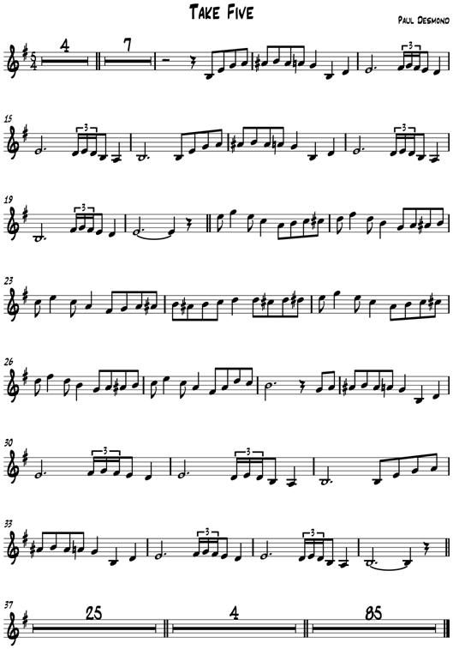

Resource 2: Unmarked score for “Spring” from The Four Seasons by Vivaldi
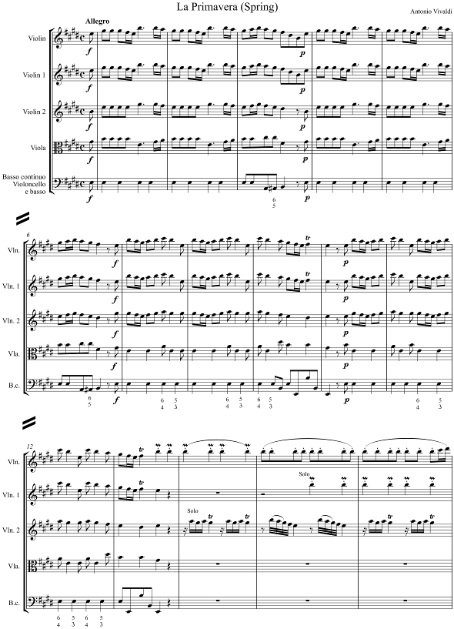
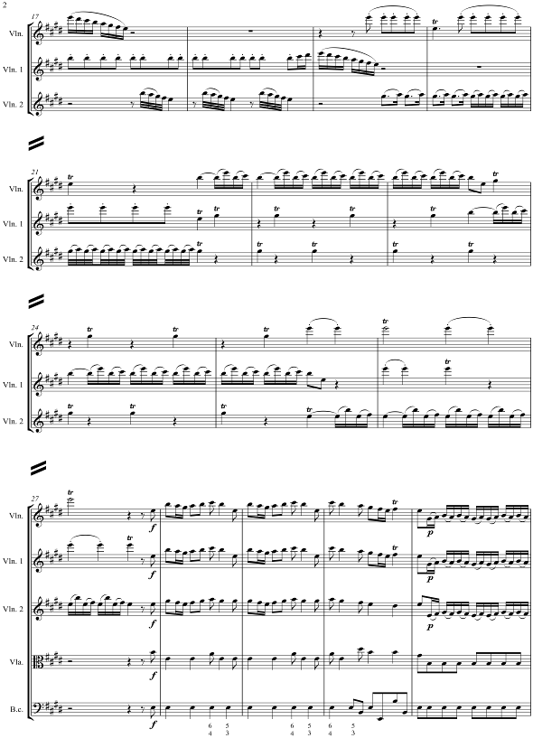
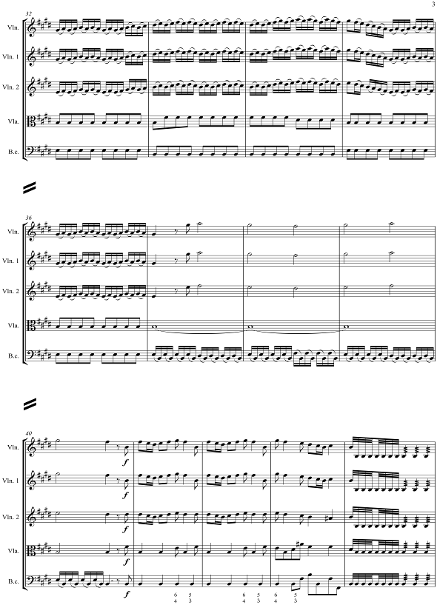
Resource 3: Extracts from “Winter” from The Four Seasons by Vivaldi
First Movement – Allegro non molto
Example: Extract A. Trembling with cold amid the silvery snow
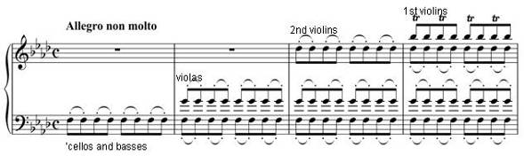
Element(s)/Compositional Device(s): Pedal point OR trills
Definition and explanation of how this matches the words:
Pedal point (‘cellos and basses). A pedal point can either be a long held note or a series of repeated notes. In this extract, it is a tonic pedal (F minor). Because the note does not move, it suggests the feeling of stillness after a snowfall.
OR
A trill consists of two notes (the principal note and the note above) played very quickly. Because of the speed of the music and the quaver movement, there is little possibility of playing the notes more than once (effectively turning the trill into a mordent). Trills above each note (bar 4 – Violin I) suggest trembling.
B Beaten by a horrid icy wind
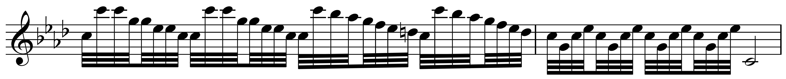
C We run, stamping our feet at every pace
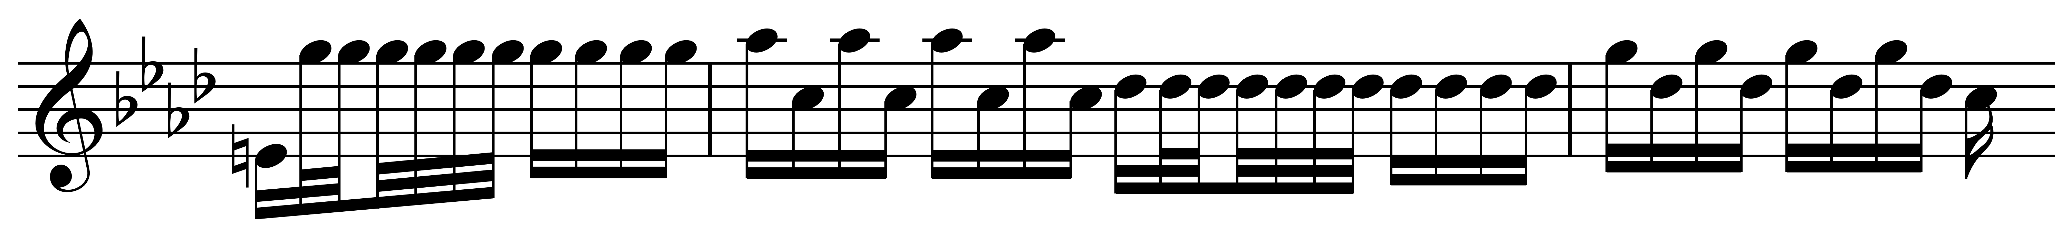
D Unable to still the chattering of our teeth
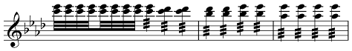
Second Movement – Largo
E To spend quiet and contented days by the fireside while, outside, the rain soaks everyone
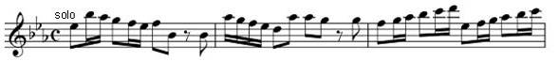
Third Movement – Allegro
F We walk on the ice with slow and timid steps
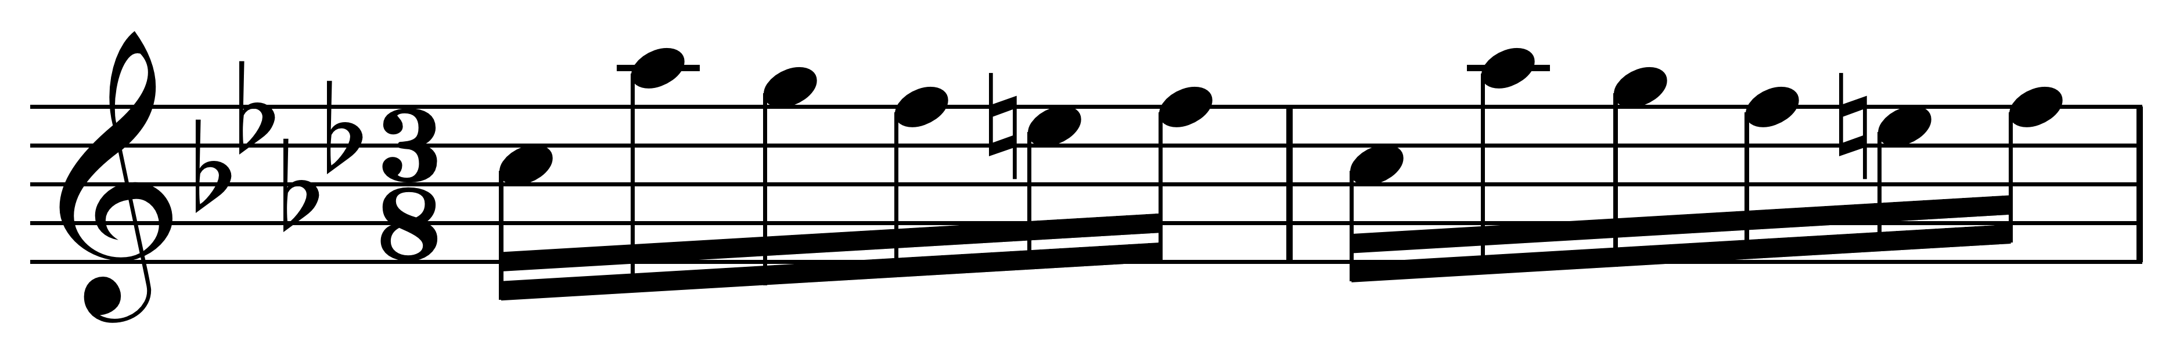
G And with great care, for fear of slipping
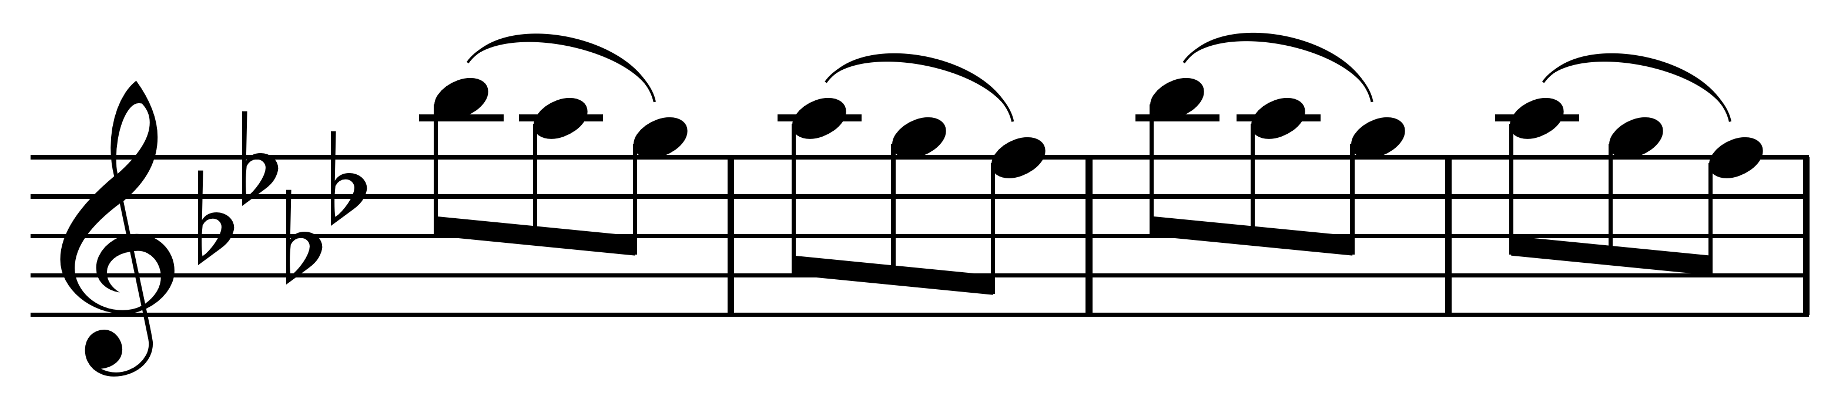
H One swift move – you crash to the ground
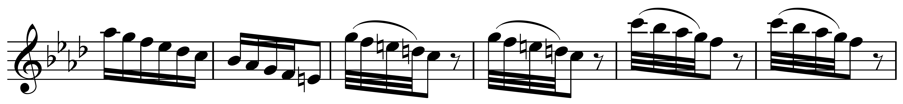
I We get up, and again run on the treacherous ice
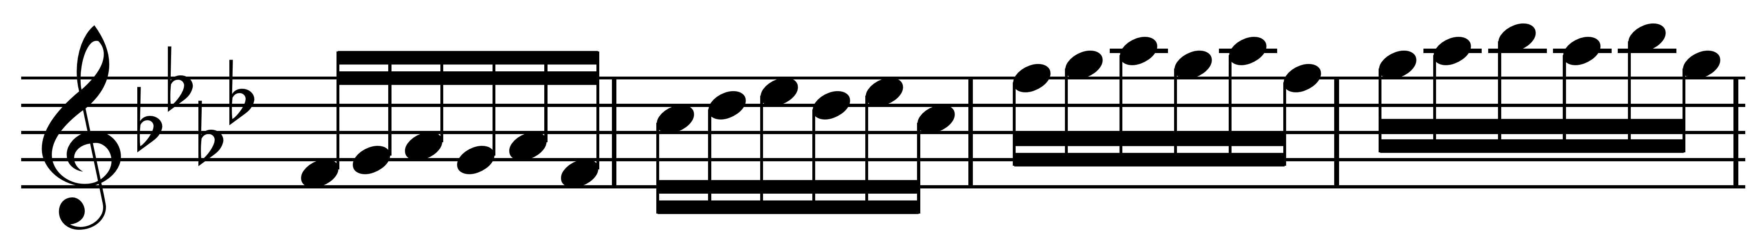
J Till it cracks and splits with a crunchy sound
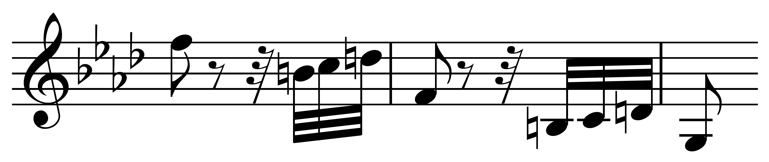

Teacher Resource
Evidence statements
The following are some examples of evidence that might be offered by students for part 1 of this assessment activity.
“Take Five” analysis evidence
- Melody, for example, the use of riffs/ostinato, head, anacrusis, sequence, how the sax melody is varied in the improvisation, the blues scale and its flattened notes
- Rhythm, for example, the use of syncopation, swung rhythm
- Harmony, for example, differences between the first and second sections, the use of chords with added 6ths, 7ths and 9ths, vamp
- Dynamics, for example, changes dynamics in the drum improvisation
- Texture, for example, how the texture changes from thin to thick at the beginning, changes of texture in the drum improvisation
- Timbre (tone colour), for example, the instruments used, the rhythm section, solo instruments
- Form (structure), for example, an explanation of the different sections as well as explaining the overall form
- Instrumental techniques for the solo instruments, for example, use of smear (in sax improvisation) and the use of flam and textural density (in drum improvisation).
“Take Five” context evidence
The student:
- shows some understanding of the characteristics of the style of cool jazz;
- provides information about one other jazz style, for example, swing or Dixieland/trad jazz, or bebop, or any modern jazz style, and describes dates/eras, groups, soloists, and songs relevant to the style and explains what gives the jazz style they choose its particular sound (for example, the style of improvisation; numbers of players).
The Four Seasons evidence statements
Identifying elements and explaining the structure
The following are some examples of evidence that might be offered by students when identifying elements and explaining the structure of The Four Seasons in Task 2 of this assessment activity. Other responses and answers are possible.
Baroque concerto
- A Baroque concerto is called concerto grosso.
- It consists of a small group of instruments contrasted with a larger group.
- The small group is called the concertante (or concertino); the large group is called the ripieno.
- The large group usually consists of strings.
- A harpsichord forms part of the ripieno.
- The instrumentation of the small group varies – it can be strings, but it can also contain brass or woodwind instruments.

Classical/Romantic concertos
For example, (other responses and answers are expected)
- They consist of a single instrument (occasionally two) contrasting with a full orchestra.
Similarities of “Spring” to other Baroque concertos
For example, (other responses and answers are expected)
- The large body (ripieno) is entirely strings.
Differences from other Baroque concertos
For example, (other responses and answers are expected)
- There is only one solo instrument.
The form of “Spring”
The answer will include the Italian term. Characteristics
For example, (other responses and answers are expected)
- The ritornello (or the main theme, which keeps returning) is played by the full orchestra (ripieno).
An explanation of elements and features used in the phrases of the opening ritornello
Phrase 1
For example, (other responses and answers are expected)
- Contraction – the phrase is only three bars long (instead of four).
Phrase 2
For example, (other responses and answers are expected)
- Irregular – the phrase is only two and a half bars long.
Figures
For example, (other responses and answers are expected)
- These are the figures the harpsichord player uses to realise (make up) the part. The player reads from the cello line and harmonises it.
- 6/3 figuring indicates a first inversion chord, and 6/4 indicates a second inversion chord
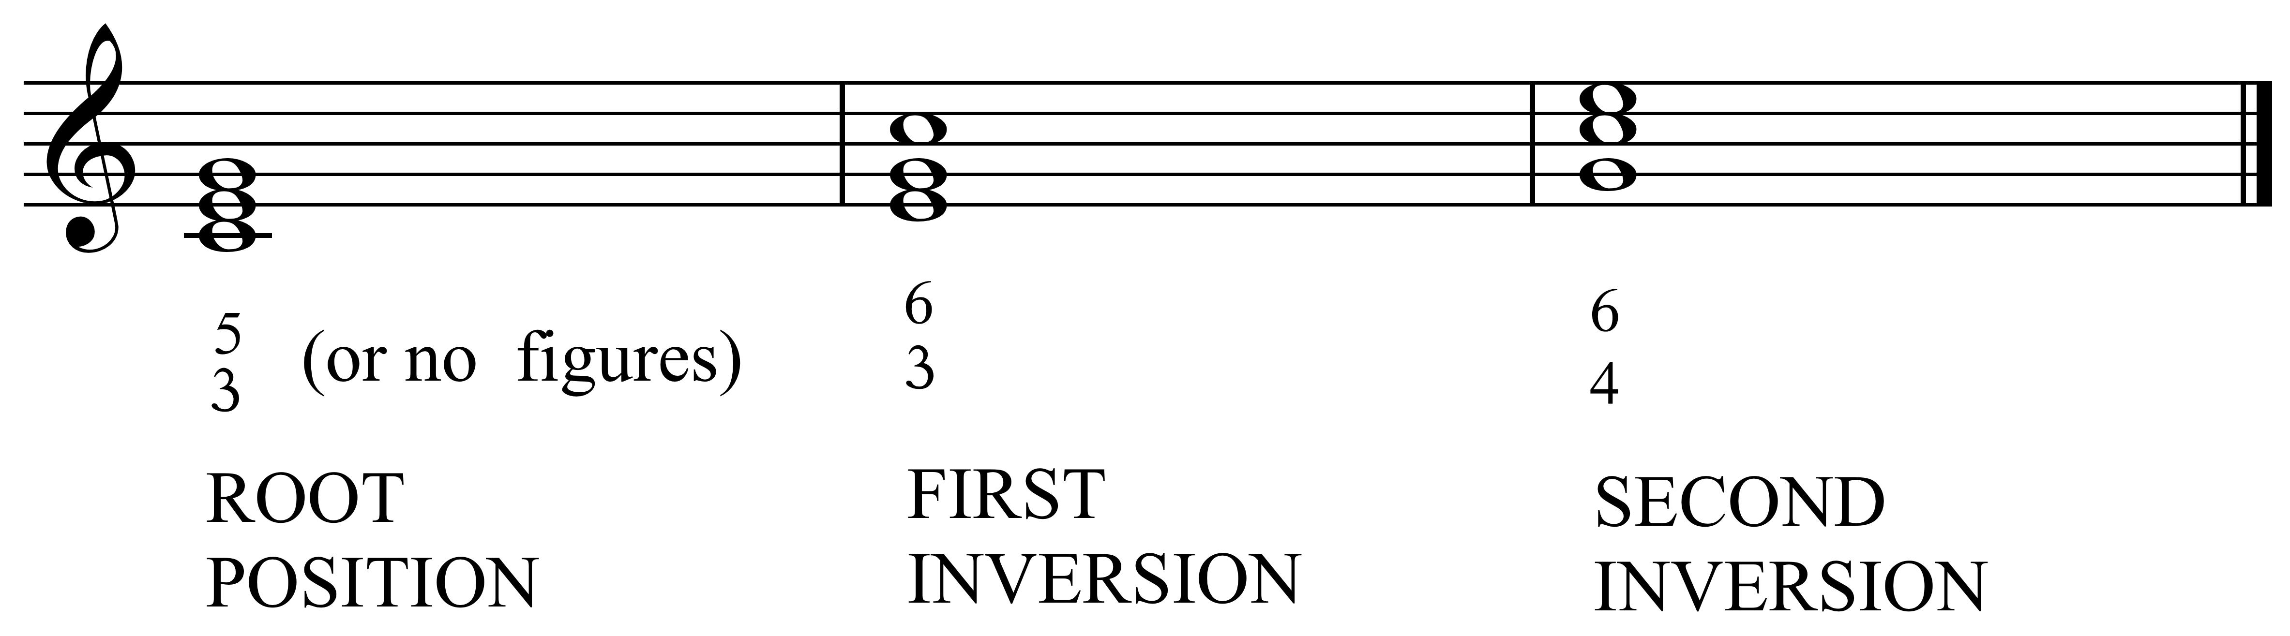
Applying knowledge of elements and features used in “Spring” to “Winter”
The following are some examples of evidence that might be offered by students when applying knowledge of elements and features used in “Spring” to “Winter” (from The Four Seasons) in Task 2 of this assessment activity. Other responses and answers are expected. .
Extract A
See Resource 3. A possible response for Extract A is given as an example for the students.
Extract B
For example,
- The repetition of motifs suggests the continuity of the head wind.
Extract C
For example,
- Repeated minor 6ths suggest the stamping of feet.
Extract D
For example,
- Repeated demisemiquavers (tremolo) imitate the chattering of teeth.
Extract E
For example,
- The tempo (largo – slowly) and note values contrast with what has gone before and suggest contentment.
Extract F
For example,
- The repetition of each bar suggests timidity and cautiousness.
Extract G
For example,
- Slurs represent the smoothness of the snow and that it might be slippery.
Extract H
For example,
- The downward melodic contour for nearly two octaves describes falling, and the rests after each motif show the finality of the fall.

Extract I
For example,
- The upward melodic contour matches “we get up”. The same motif is also repeated sequentially, a little higher each time.
Extract J
For example,
- The jagged melody suggests the contour of ice splitting.

Planning a concert of Baroque music
The following are some examples of evidence that might be offered by students when planning a concert of Baroque music in Task 2 of this assessment activity. Other responses and answers are possible.
Choice of instruments
- The choice of instruments should only include Baroque instruments.

- Baroque orchestras were small.
Choice of music
- The music chosen should be entirely by Baroque composers.
- The concert should last one-and-a-half to two hours.
Poster
- The poster should include date, time, and venue.
- Any illustrations should reflect the Baroque period.
Article
- The paragraph about three chosen works should reflect accurately the resources used.
- For “Spring”: the use of a harpsichord makes it authentically Baroque.
- One solo violin, but two others need to be capable of joining the soloist (as a trio).
- Small string orchestra.
- Differences between violins in the Baroque period.
- The orchestra is to be led by the solo violin rather than having a conductor.
Programme notes
The programme notes might include the following information:
- Vivaldi’s dates.
- Year it was composed..
- Instruments it was composed for.
- Each concerto is based on a descriptive sonnet.
- Whom it was dedicated to.
- An explanation of programme music.
- Vivaldi’s contribution to concerto form.

Assessment Schedule: Music 91095 Take Four and Five
Evidence/Judgements for Achievement | Evidence/Judgements for Achievement with Merit | Evidence/Judgements for Achievement with Excellence
The student has demonstrated knowledge of two music works from contrasting contexts: the jazz work “Take Five” and Vivaldi’s The Four Seasons.  To do this, they have:  - made comments about the use of elements, features, and compositional devices in “Take Five”, performance practices used in the improvisations, and the form of the music, supported by some explanations and/or musical examples (see example 1 below)  - commented about the context of cool jazz and one other jazz style (see example 2 below)  - identified differences between the baroque concerto and classical and romantic concertos and compared “Spring” with typical baroque concertos  - correctly identified musical features, by:  - describing the form of “Spring”, including identifying the beginning of three sections on the score  - identifying the two main phrases, through annotating the score and explaining a characteristic of each  - explaining the significance of the figures  - explaining the link between at least four lines of Vivaldi’s poem and the musical features of “Winter”  - planned a concert of baroque music, choosing appropriate instruments and music  - produced a publicity article containing valid information about The Four Seasons and one other work, including information on the choice of instruments  - produced a programme note containing information on the composer, when the music was composed, and a personal statement about the music (see example 3 below). | The student has demonstrated breadth of knowledge of two music works from contrasting contexts: the jazz work “Take Five” and Vivaldi’s The Four Seasons.  To do this, they have:  - made valid comments about the use of elements, features, and compositional devices in “Take Five”, performance practices used in the improvisations, and the form of the music, supported by sound explanations and/or musical examples (see example 1 below)  - commented in some detail about the context of cool jazz and one other jazz style (see example 2 below)  - identified a number of differences between the baroque concerto and classical and romantic concertos and compared “Spring” with typical baroque concertos  - correctly identified musical features, by:  - describing the form of “Spring” in detail, including identifying the beginning of four sections on the score  - identifying the two main phrases and repeats, through annotating the score and explaining a characteristic of each, using correct technical terms  - explaining the significance of the figures, using technical terms  - explaining the link between at least five lines of Vivaldi’s poem and the musical features of “Winter”  - planned a concert of baroque music, choosing appropriate instruments (including a harpsichord) and music  - produced a detailed publicity article containing valid information about The Four Seasons and one other work, including information on the choice of instruments  - produced a programme note containing detailed information on the composer, when the music was composed, how performance practices differed from those of today, and a coherent personal statement about the music (see example 3 below). | The student has demonstrated comprehensive knowledge of two music works from contrasting contexts: the jazz work “Take Five” and Vivaldi’s The Four Seasons.  To do this, they have:  - made detailed comments about the use of elements, features, and compositional devices in “Take Five”, performance practices used in the improvisations, and the form of the music, supported by insightful explanations and/or pertinent musical examples (see example 1 below)  - commented in detail about the context of cool jazz and one other jazz style (see example 2 below)  - identified several differences between the baroque concerto and classical and romantic concertos and compared “Spring” with typical baroque concertos  - correctly identified musical features, by:  - describing the form of “Spring” in detail, including identifying the beginning of all sections on the score and identifying where sections are incomplete  - identifying the two main phrases and repeats and subsections, through annotating the score and explaining a characteristic of each, using correct technical terms  - explaining the significance of the figures, using technical terms and explaining how the figures relate to the chords  - explaining the link between at least six lines of Vivaldi’s poem and the musical features of “Winter”  - planned a balanced concert of baroque music, choosing appropriate instruments (including a harpsichord) and music  - produced a detailed publicity article containing in-depth information about The Four Seasons and two other works, including information on the choice of instruments  - produced a programme note containing in-depth information on the composer, when the music was composed, how performance practices differed from those of today, and an insightful personal statement about the music (see example 3 below).
Example 1  “The opening melody is played by saxophone. It is called the head. The second theme is built on a one-bar riff, which is developed as a sequence.” The student demonstrates/describes swung and straight rhythm. “There is also syncopation. This means that the music is off-beat.” | Example 1  “The opening melody, the head, is played by alto saxophone. The theme is built on the blues scale of E. The second theme is built on a contrasting one-bar riff, which is developed as a sequence (the riff is repeated twice more, a note lower each time).” The student also plays at least one of these themes and/or points out their position on the score (or annotates the score for written assessment).  The student demonstrates/describes swung and straight rhythm and explains that it is the quavers that are swung. “There is also syncopation. This means that the music is off-beat.” The student either plays or shows on the score the syncopated riff from the second theme. | Example 1  “The opening melody, the head, is played by alto saxophone. The theme is built on the blues scale of E. Notes 3, 5, and 7 are flattened”.  The student demonstrates by playing the blues scale or showing the flattened notes on the score (or writing out). “The second theme is built on a contrasting one-bar riff, which is developed as a sequence. (The riff is repeated twice more, a note lower each time.)”  The student also plays both of these themes and/or points out their position on the score (or annotates the score).  The student demonstrates/describes swung and straight rhythm and explains that it is the quavers that are swung. “There is also syncopation. This means that the music is off-beat.” The student either plays or shows on the score the syncopated riff from the second theme. The student is also able to play or show on the score the repeated syncopation of the vamp (and explains what a vamp is).
Example 2  “Cool jazz first appeared in the 1960s and was a reaction to the complicated style of bebop. The name ‘cool’ suggests the relaxed style of the music. The Dave Brubeck Quartet was one of the leading groups playing cool jazz. They sometimes used instruments that had not featured in earlier jazz styles (for example, the flute). An example of music in cool jazz style is “The Pink Panther”.  Dixieland jazz began in New Orleans in the 1920s. Generally Dixieland groups were quite small (between three and eight players). One of the leading musicians in this style was Louis Armstrong, who played the trumpet and is famous for his performance of “When the Saints Go Marching In”. There was a lot of improvisation and syncopation (off beat rhythm)”. The student plays a recording of “When the Saints Go Marching In”. | Example 2  “Cool jazz first appeared in the 1960s and was a reaction to the complicated style of bebop. It generally had smooth melodies that were easy to listen to and sometimes used unusual time signatures (for example, “Take Five”). The name “cool” suggests the relaxed style of the music. The Dave Brubeck Quartet was one of the leading groups playing cool jazz. Others were the Swingle Singers and Miles Davis. They sometimes used instruments that had not featured in earlier jazz styles (for example, the flute and French horn). An example of music in cool jazz style is Henry Mancini’s “The Pink Panther”.  Dixieland jazz (also known as trad jazz) began in New Orleans in the 1920s. Generally Dixieland groups were quite small (between three and eight players). One of the leading musicians in this style was Louis Armstrong, who played the trumpet and sang and is famous for his performance of “When the Saints Go Marching In”. There was a lot of improvisation and syncopation (off-beat rhythm).”  The student plays music of “When the Saints Go Marching In”, and points out an improvisation by Louis Armstrong on the trumpet. “Dixie bands featured two groups of players; the frontline instruments who played the melody, and the rhythm section. The piano often used a boogie bass.” (The student demonstrates or explains what this is.) | Example 2  “Cool jazz first appeared in California in the 1960s and was a reaction to the angular and complicated style of bebop. It generally had smooth melodies that were easy to listen to and sometimes used unusual time signatures (for example, “Blue Rondo a la Turk”, which was written in 9/8 but had accents falling on beats 1,3,5 and 8 instead of the usual 1, 4 and 7). The name “cool” suggests the relaxed style of the music. Because the groups were small, the texture was light and it was easy to hear each melodic line. The Dave Brubeck Quartet was one of the leading groups playing cool jazz. Others were the Swingle Singers, a vocal group who “jazzed up” Bach’s music and used scat singing (nonsense words such as “do be do”), and Miles Davis. They sometimes used instruments that had not featured in earlier jazz styles (for example, the flute, French horn, and vibraphone). An example of music in cool jazz style is the opening of Henry Mancini’s “The Pink Panther” (the second section features a “big band”).  Dixieland jazz (also known as trad jazz) began in New Orleans in the 1920s. Generally Dixieland groups were quite small (between three and eight players). One of the leading musicians in this style was Louis Armstrong, who played the trumpet, sang, and composed, and is famous for his performance of “When the Saints Go Marching In”. Another well-known piece by Louis Armstrong is “What a Wonderful World”. His band was known as The Hot Five. There was a lot of improvisation and syncopation (off-beat rhythm).”  The student plays music of “When the Saints Go Marching In” and points out an improvisation by Louis Armstrong on the trumpet and also remarks on the gravelly quality of his voice). “There were two different types of improvisation. The first is solo improvisation, where one instrument makes up a new tune based on the chords played by the rhythm section. The second is where more than one instrument (for example, a trumpet, clarinet, and trombone) all improvise together and play different tunes”.  The student gives examples of each, for example, from “Muskrat Ramble”. “Dixie bands featured two groups of players; the frontline instruments who played the melody, and the rhythm section (for example, a banjo, guitar, or keyboard, and bass and drums). The piano often used a boogie bass.” (The student demonstrates or explains what this is.)
Example 3  For example: “The Four Seasons was written by Antonio Vivaldi (1678–1741). The Four Seasons is Vivaldi's best-known work, and is among the most popular pieces of baroque music. “Spring” is the first concerto and has three movements – quick, slow, quick. The Four Seasons is one of the earliest examples of programme music (music that tells a story). Vivaldi wrote the text that goes with the music. A solo violin is used.  I enjoyed the way that Vivaldi’s music matches the description of each scene very well.” | Example 3  “The Four Seasons was composed in 1723 by Antonio Vivaldi (1678–1741). The Four Seasons is Vivaldi's best-known work and is really four separate concertos. It was dedicated to Count Marzin and first performed by his orchestra. “Spring” is the first of the four concertos, and as was usual for Baroque concertos, has three movements – quick, slow, quick. The Four Seasons is one of the earliest examples of programme music (music that tells a story or depicts a mood). Vivaldi wrote the text that goes with the music. A solo violin is used rather than the more usual group of instruments contrasting with the full orchestra.  I enjoyed Vivaldi’s depiction of birds singing in the first movement (using trills) and the viola imitating a dog barking in the second movement.” | Example 3  “The Four Seasons was composed in 1723 by Antonio Vivaldi (1678–1741). The Four Seasons is Vivaldi's best-known work and is really four separate concertos. It was dedicated to Count Marzin and first performed by his orchestra. The original instrumentation was for solo violin accompanied by solo strings.  “Spring” is the first of the four concertos, and as was usual for baroque concertos, has three movements – quick, slow, quick. The Four Seasons is one of the earliest examples of programme music (music that tells a story or depicts a mood). Vivaldi wrote the text that goes with the music.  A solo violin is used rather than the more usual group of instruments contrasting with the full orchestra. This helped to set the instrumentation that classical composers used. Sometimes the solo violinist plays alone, accompanied by the ripieno (for example, bars 47–55), and sometimes two other violins from the orchestra join as soloists creating a string trio (rather more like other baroque concertos).  Altogether Vivaldi wrote over 500 concertos, many of them for solo instruments.  I particularly enjoyed Vivaldi’s depiction of birds singing in the first movement (using trills) and the viola imitating a dog barking in the second movement. It is surprising the variety of effects Vivaldi is able to describe musically using only strings. The brightness (E major) and energy of the forward-moving baroque rhythm were also highlights for me.”
Final grades will be decided using professional judgement based on a holistic examination of the evidence provided against the criteria in the Achievement Standard.

